QR Code Reader

1. Requirement:  
   Detecting QR, Barcode from Image sent to the server as a request.
2. Flow-Diagram:  
   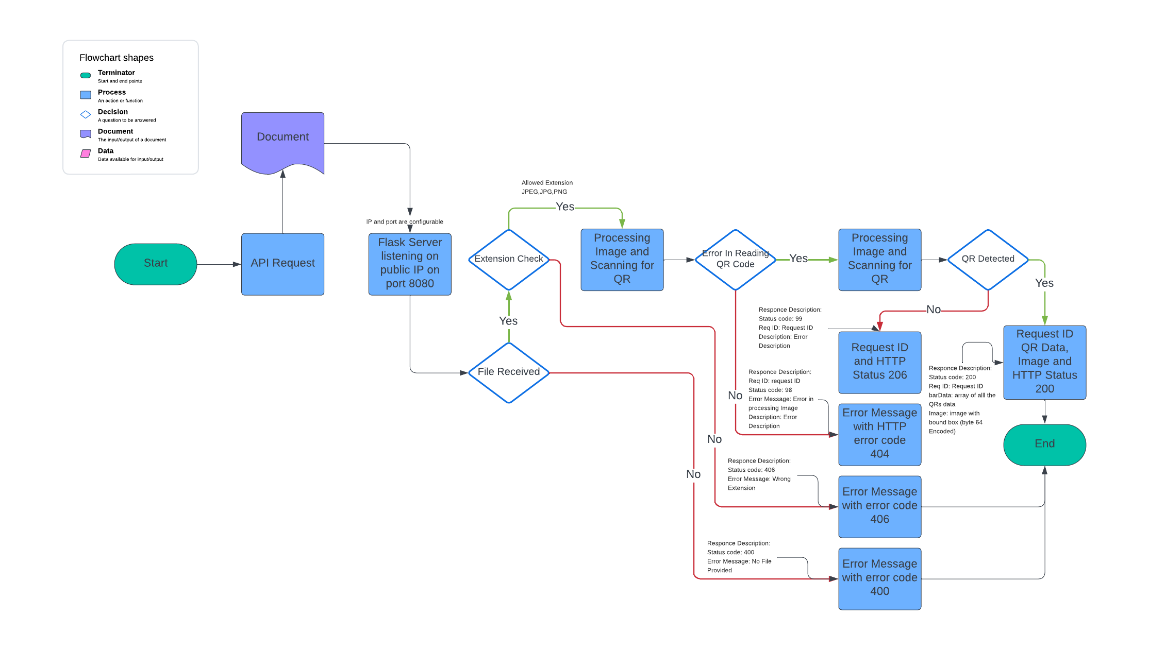
3. Dependencies:
   1. Python 3.10
   2. Pip
   3. Flask (pip install flask)
   4. Libzbar0 (sudo apt -get install libzbar0)
   5. Pyzbar (pip install pyzbar)
4. Description:
   1. First we are accepting Image file on port 8080
   2. We are checking if we have image file in request or not if not then appropriate error message is generated and send in the response
   3. We are checking if the file sent is in proper extension or not, Accepted formats are JPEG, JPG, PNG
   4. Then we are processing the image and decoding the QR data
   5. If any error while image processing or not able to read the barcode data error message is generated with custom status code 98 and sent along with request ID
   6. Bound box is created around the scanned data
   7. All the QR data is added to array structure then encapsulated under barData field in JSON response , along with Image and request ID
5. Test Document:   
   